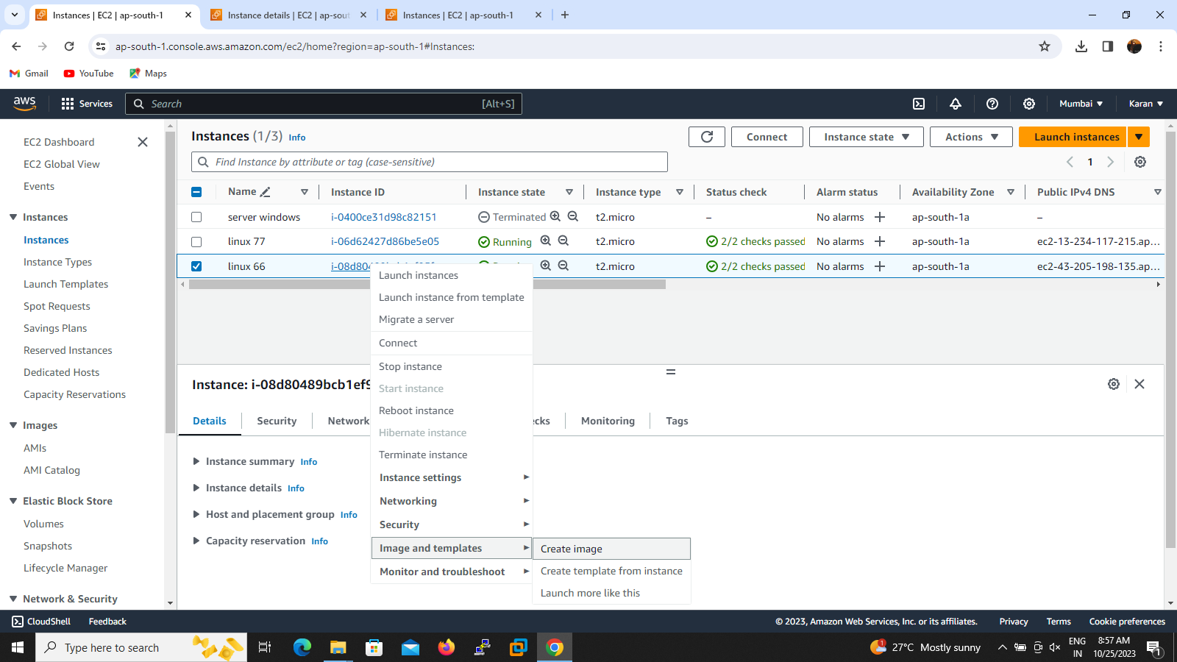

1.create an instance in Mumbai region and we want to migrate the instance so do the first step click the instance id .Then select create image and fill the given describtion box ,I named migration Ireland

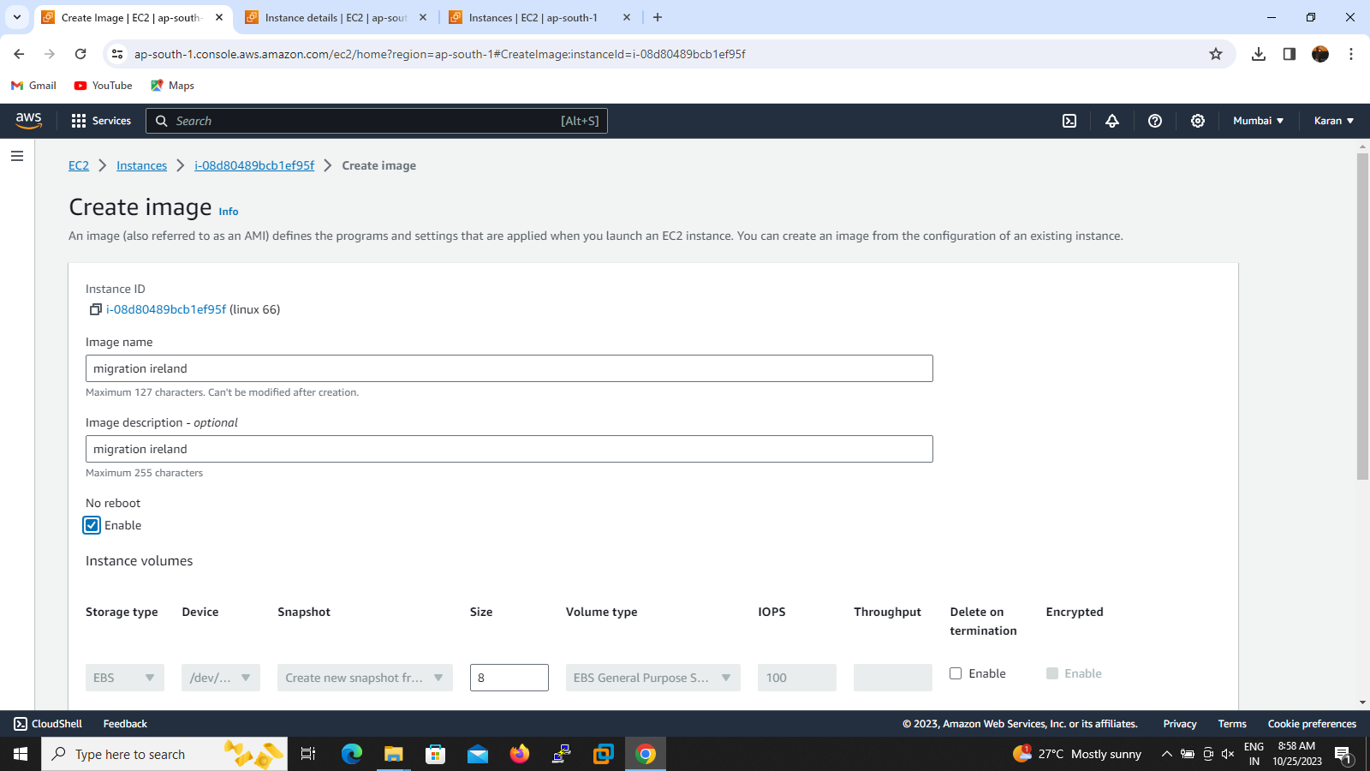

2.During ami creation time we don’t want get reboot so tick the box and create image

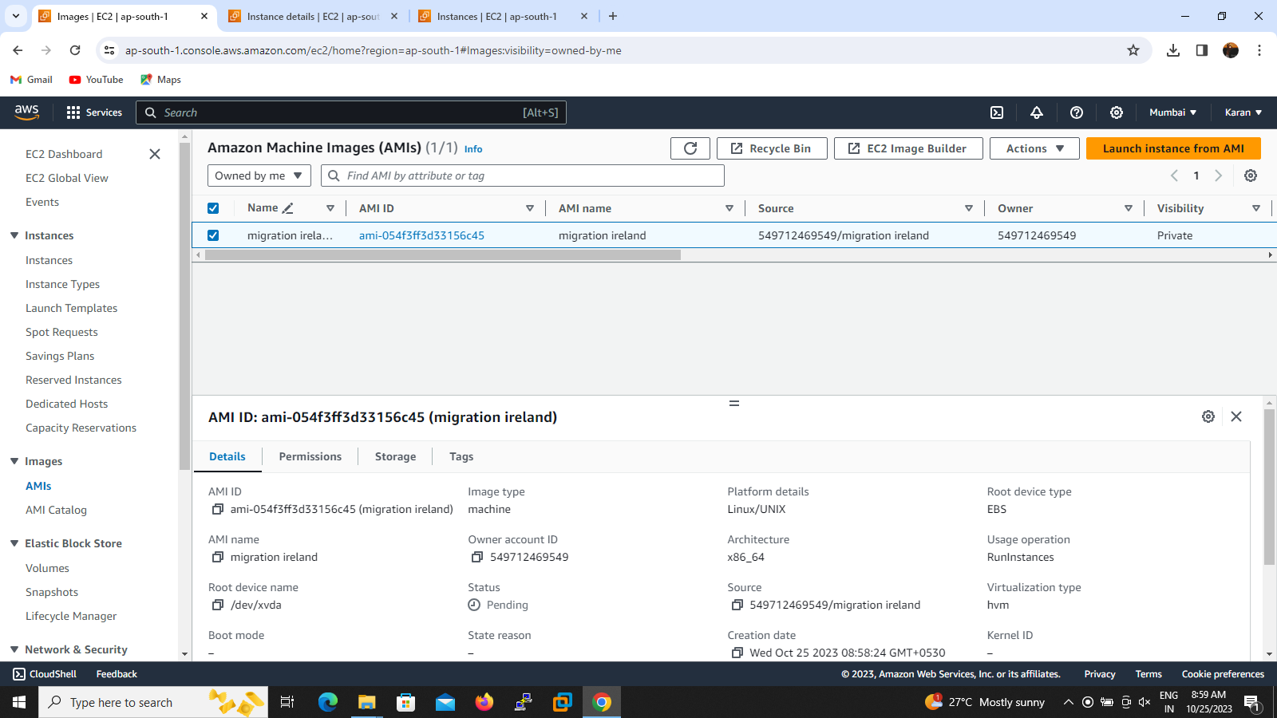

3.Go to the ami successfully created then right click the ami id then click copy ami

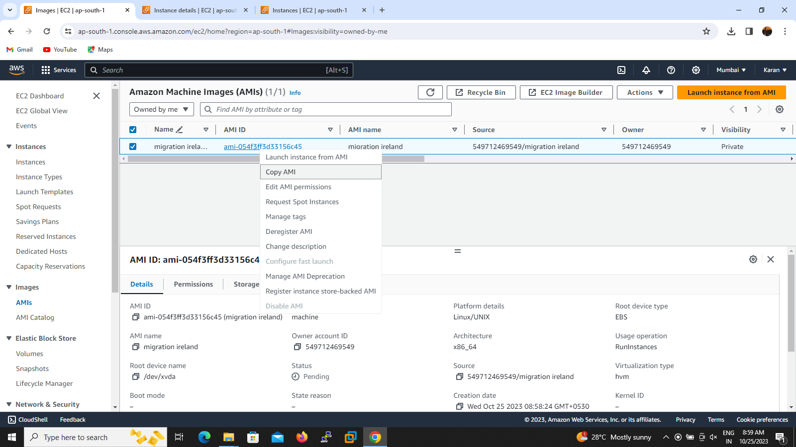

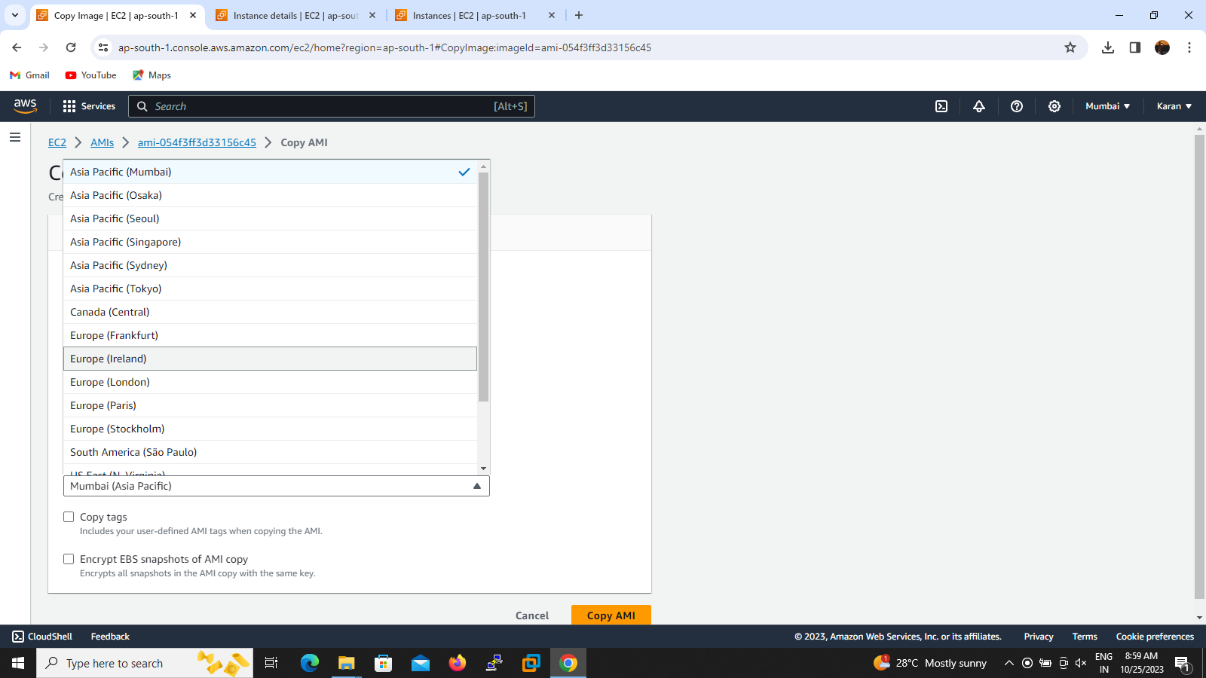

4.Copy the ami id and fill which region we want to migrate then copy ami

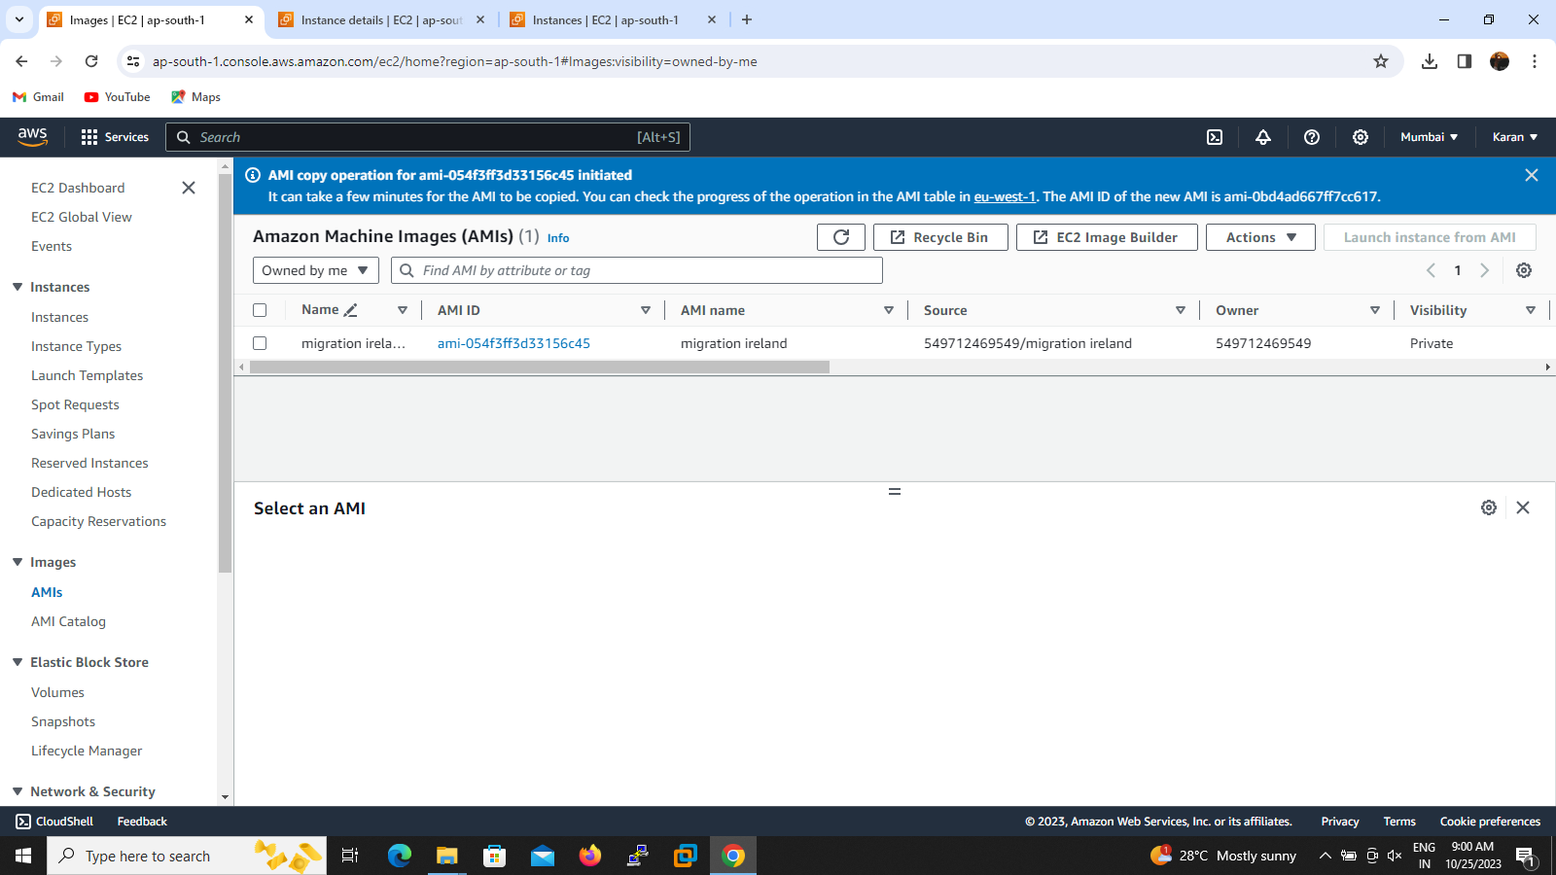

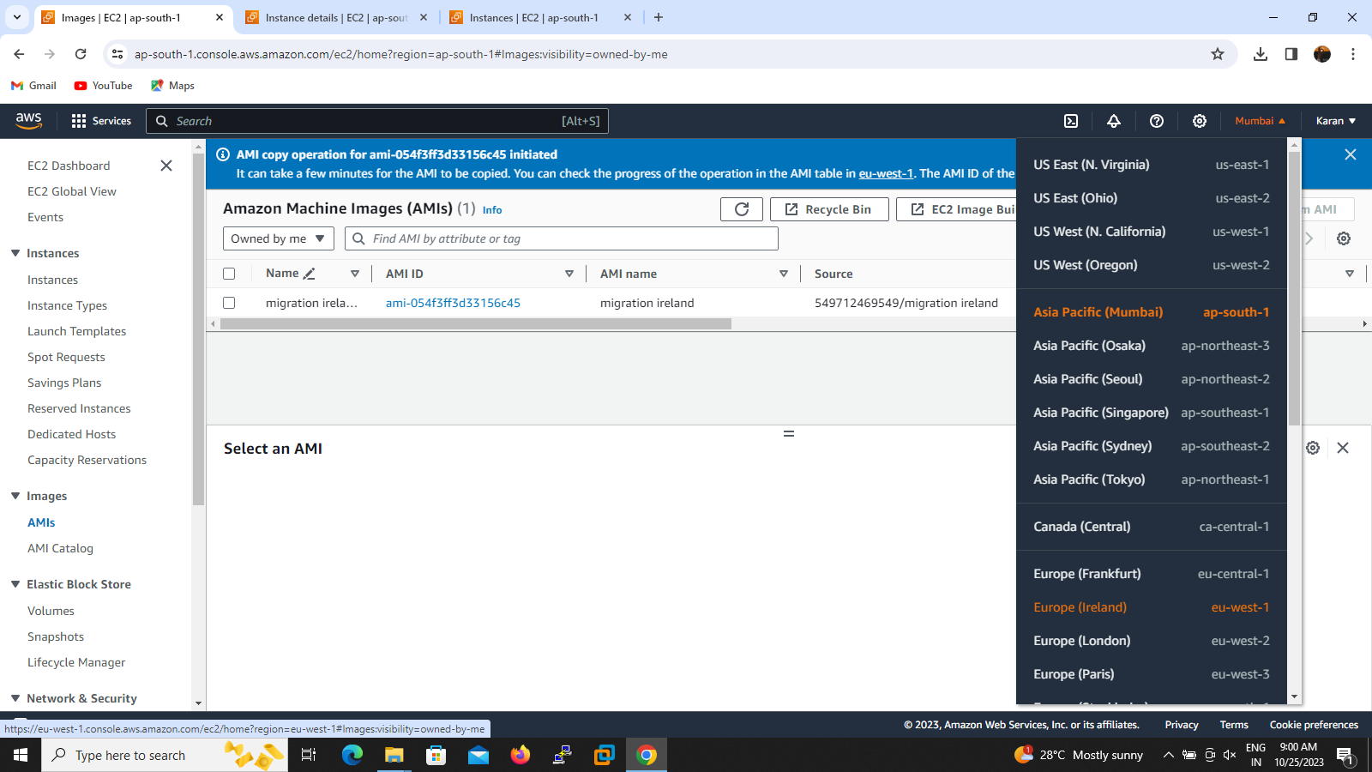

5.then the copy ami successfully initiated to required region .if we want to check then click the region I given Ireland so I will click Ireland and check ami option initiated ami will show up

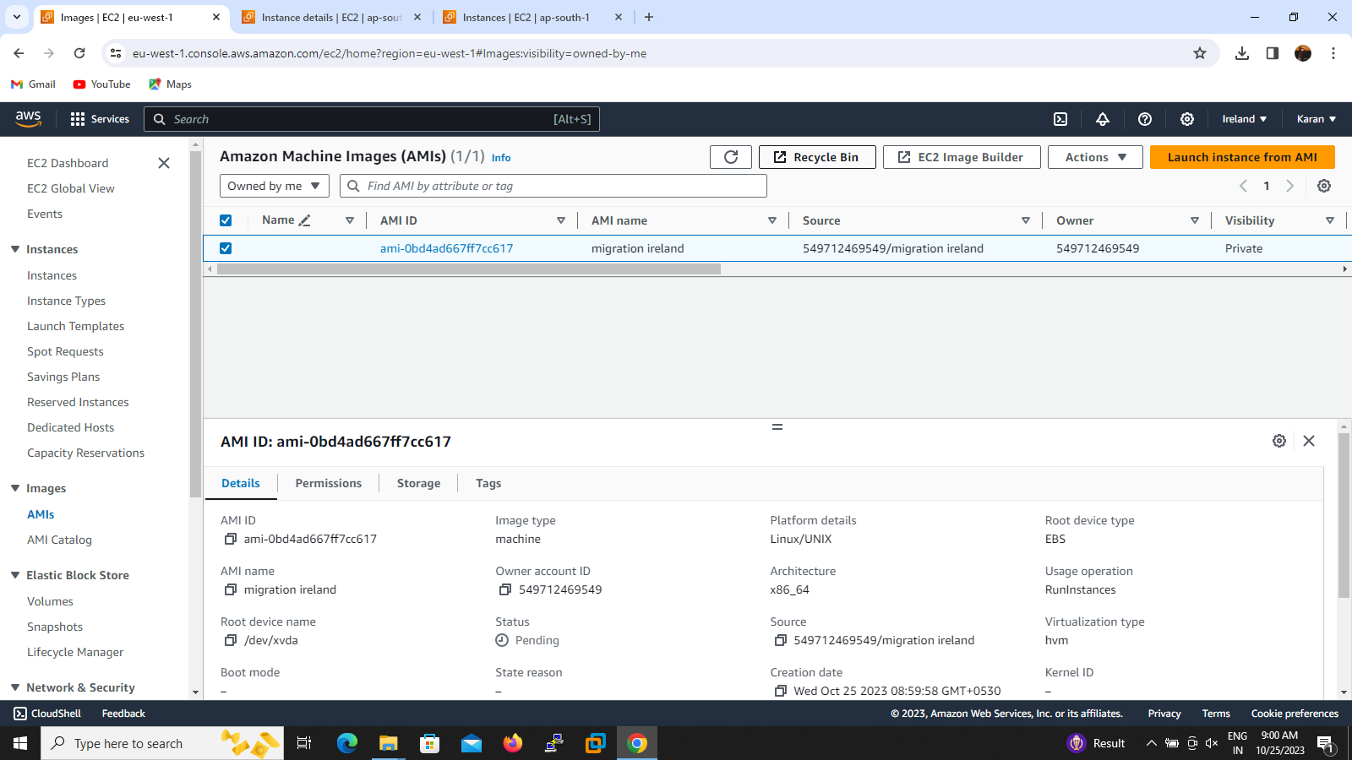

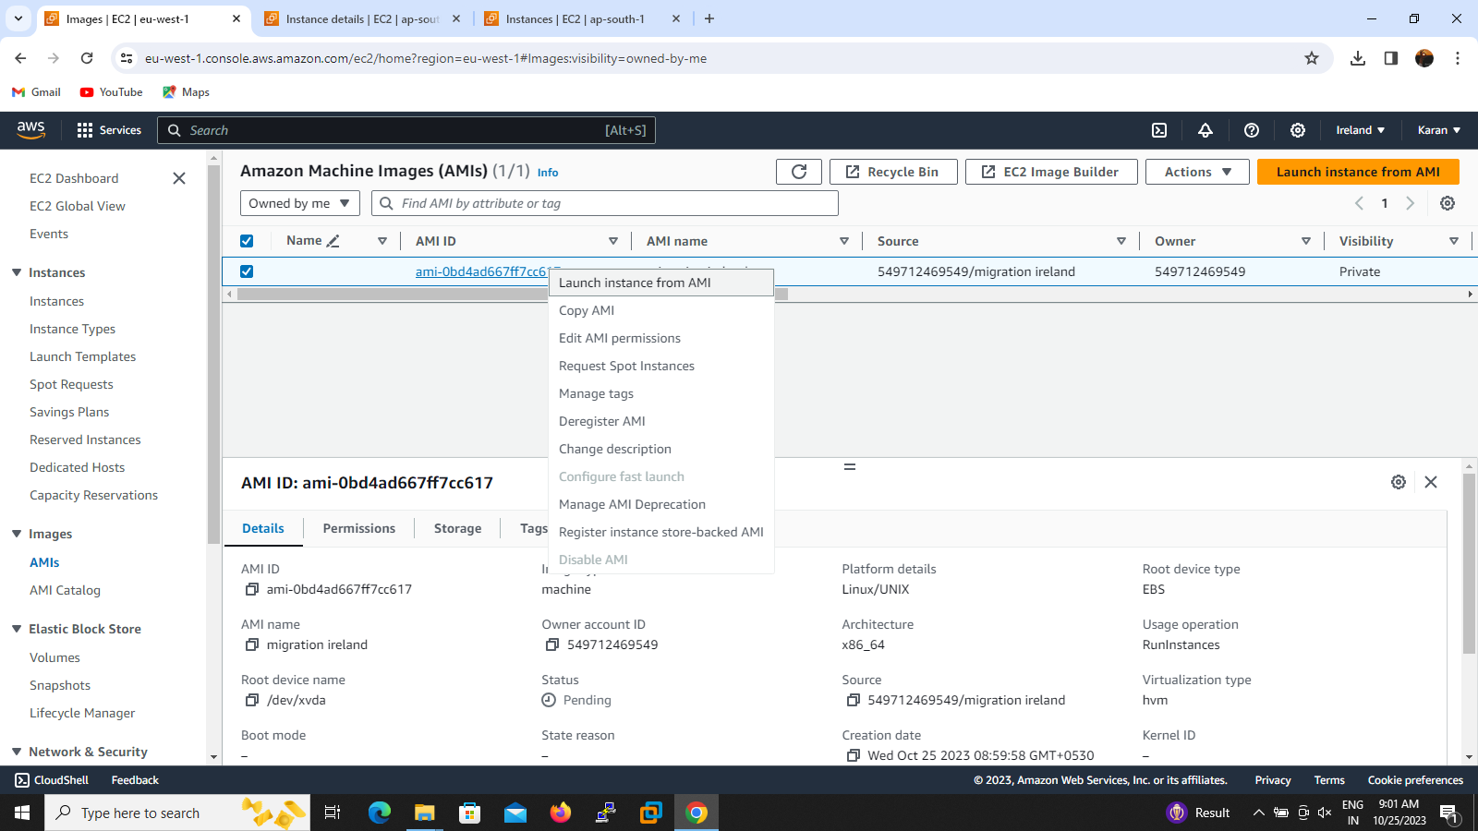

6.if we want to lauch the instance ,then we can click launch instance from ami option to launch the server